

Insert subject image here, size 8x12cm

Drive Cycle Generator - Gen 1

Akshat Dagdi, Matthew Fulford, Rostislav Zinovyev
Date: 05/11/2025
Word Count: XXXX

Supervisor:
Assessor:

Executive Summary

Table of Contents
Executive Summary ii
Table of Contents ii
1. Summary 2
2. Track Definition 2
2.1. Centreline 2
2.2. Path optimisation 2
3. Velocity solver 5
3.1. Parameter setup 5
3.2. Idealised velocity limit 6
3.3. Force driven velocity 7
4. Drive Cycle Results 8
4.1. Velocity profile 8
4.2. Applied force 9
4.3. Lean angle 10
4.1. Power Demand 10
5. Appendix 12
5.1. Aragon track data 12
5.2. MotoStudent ME1616 motor data sheet 12

List of Figures
Figure 1 - Minimum curvature racing line. 4
Figure 2 - Peak power to Motor RPM lookup table 5
Figure 6 - Bike velocity in comparison to physical speed limit against time 8
Figure 7 – Bike velocity around track geometry 9
Figure 3 - Drive Cycle velocity profile to Power demand. 10
Figure 4 - Parallel cell count approximation for 8 push lap performance. 11
Figure 5 - Parallel cell requirement for a gear ratio of 1.24. 11

List of Table
Table 1 - Drive cycle physical parameters 6

List of Symbols and Acronyms
MCP Minimum Curvature Path
v Velocity
g Acceleration due to Earth’s gravity
κ Curvature
Gen 1 Generation 1 simulation
J Optimum curvature offset from centreline
RPM Rotations Per Minute
Φ Roll angle
Θ………………………………………………………………………………………….…Track slope
µ Coefficient of Friction
r Corner Radius
$F_{drag}$………………………………………………………………………………...………Drag Force
$F_{roll}$……………………………………………………………..……………Rolling resistance Force
$F_{grav}$…………………………………………………………….…………....Grade resistance Force
$C_{d}$……………………………………………………………………………………... Drag Coefficient
A……………………………………………………………………………………………Frontal area

Summary
This report documents the theory and use of the Gen1 Drive Cycle Generator Simulation developed within the team as an adaption of Akshat Dagdi’s final year project from Loughborough University using theory from Vittore Cossalter’s Motorcycle Dynamics [1] to model the racing performance of Bath Zero’s prototype motorbike.
The model generates a profile of bike velocity over 1 lap of the Aragon Ful circuit track. The Report outlines the methodology in which this velocity is calculated and the limitations in the model’s accuracy. Computationally relevant code is referenced in Section 5 and the full code is linked Appendix

Track Definition

Centreline
This section covers the code referenced in Section 5.1.
A copy of the track map was taken into CAD where [x, y] coordinates of points along the centreline of the track were plotted into a .csv file, the track width either side of the centreline were also plotted in the same csv, Aragon track data.
This data was collected for the full Aragon track including the final hairpin corner, which is not run in MotoStudent, the track was simulated with this hairpin for Gen 1 with scope to review the track definition in later simulation generations
The raw data was imported into the track processing module (processTrack.m) and resampled to produce a 1500 segment smooth centreline plot. The track widths (assumed a constant 6 m either side of the centreline) were then projected out from the centreline to form an inner and outer track boundary.

Elevation
Elevation data is taken from GPS Visualizer, coordinates [x.y] inputted to get elevation above ocean which was adjusted and appended into the 2.1 .csv file.
Raw z-data is smoothed using a Gaussian moving average filter with a window size of 25 points. This is resampled using pchip interpolation to align perfectly with the 1500 discrete segments of the centreline path. This ensures a continuous gradient angle ($θ$) can be derived.

Path optimisation
This section covers the code referenced in Section 5.2.
The velocity with which the bike can travel round a corner is inversely proportional to the curvature of the corner. In order to ride the bike at its maximum possible speed around the track, the curvature must be minimised. The MCP (Minimum Curvature Path) optimisation method is used to find this path outputting the racing line as a normalised offset from the centreline between the track boundaries, where $a=0$ represents the inner track boundary and $a=1$ represents the outer boundary.
The optimisation goal is to minimise the sum of squared local curvatures (approximated as the second derivative of the path coordinates). This method involves the generation of two matrices, H and B.

- H Matrix (Cost Matrix): Symmetric matrix that defines the ‘cost’ of the path’s shape. Calculated in a numerical iterative process, calculating a 3x3 matrix around each index in the matrix (i-1,I,i+1)
  - Diagonal terms (Squared terms): Represent the penalty for sharp angles at specific nodes
  - Off-diagonal terms (Cross terms): Represent the interaction between neighbouring points. These terms ‘reward’ the solver for aligning a point with its neighbours, effectively smoothing the path

$$H\left(i-1, i+1\right)=H\left(i-1, i-1\right)+{Δ_{x}(i-1)}^{2}+{Δ_{y}(i-1)}^{2}$$
$$H\left(i-1, i\right)=H\left(i-1, i\right)-2Δ_{x}(i-1)Δ_{x}(i)-2Δ_{y}(i-1)Δ_{y}(i)$$
$$H\left(i-1, i-1\right)=H\left(i-1, i+1\right)+Δ_{x}(i-1)Δ_{x}(i+1)+Δ_{y}(i-1)Δ_{y}(i+1)$$

$$H\left(i, i-1\right)=H\left(i, i-1\right)-2Δ_{x}\left(i\right)Δ_{x}\left(i-1\right)-2Δ_{x}\left(i\right)Δ_{x}\left(i-1\right)$$
$$H\left(i, i\right)=H\left(i, i\right)+4{Δ_{x}(i)}^{2}+4{Δ_{y}(i)}^{2}$$
$$H\left(i, i+1\right)=H\left(i, i+1\right)-2Δ_{x}\left(i\right)Δ_{x}\left(i+1\right)-2Δ_{x}\left(i\right)Δ_{x}\left(i+1\right)$$

$$H\left(i+1, i-1\right)=H\left(i+1, i-1\right)+Δ_{x}(i+1)Δ_{x}(i-1)+Δ_{y}(i+1)Δ_{y}(i-1)$$
$$H\left(i+1, i\right)=H\left(i+1, i\right)-2Δ_{x}(i+1)Δ_{x}(i)-2Δ_{y}(i+1)Δ_{y}(i)$$
$$H\left(i+1, i+1\right)=H\left(i+1, i+1\right)+{Δ_{x}(i+1)}^{2}+{Δ_{y}(i+1)}^{2}$$
Where Δ_{x} and Δ_{y} are the distance components in x and y from the centreline to the boundary at each index.

- B Matrix (Geometric Constraint): Vector encodes the curvature of the fixed inner track boundary. Acts as a reference against which the solver adjusts the racing line.
$$B\left(i-1\right)=B\left(i-1\right)+2\left[{LB}_{x}\left(i+1\right)+ {LB}_{x}\left(i-1\right)-2{LB}_{x}\left(i\right)\right]* Δ_{x}\left(i-1\right)+2\left[{LB}_{y}\left(i+1\right)+ {LB}_{y}\left(i-1\right)-2{LB}_{y}\left(i\right)\right]* Δ_{y}\left(i-1\right)$$
$$B\left(i\right)=B\left(i\right)-4\left[{LB}_{x}\left(i+1\right)+ {LB}_{x}\left(i-1\right)-2{LB}_{x}\left(i\right)\right]* Δ_{x}\left(i\right)-4\left[{LB}_{y}\left(i+1\right)+ {LB}_{y}\left(i-1\right)-2y\left(i\right)\right]* Δ_{y}\left(i\right)$$
$$B\left(i+1\right)=B\left(i+1\right)+2\left[{LB}_{x}\left(i+1\right)+ {LB}_{x}\left(i-1\right)-2{LB}_{x}\left(i\right)\right]* Δ_{x}\left(i+1\right)+2\left[{LB}_{y}\left(i+1\right)+ {LB}_{y}\left(i-1\right)-2y\left(i\right)\right]* Δ_{y}\left(i+1\right)$$
Akshat, please reference your paper on path optimisation here
These matrices are used to feed a quadratic programming (QP) function which minimises the sum of squared curvatures with relation to the vector direction of the lateral offset from the centreline (α), this is solved in MATLAB using a quadprog function.
$$J= \frac{1}{2} α^{T} Hα B^{T}$$

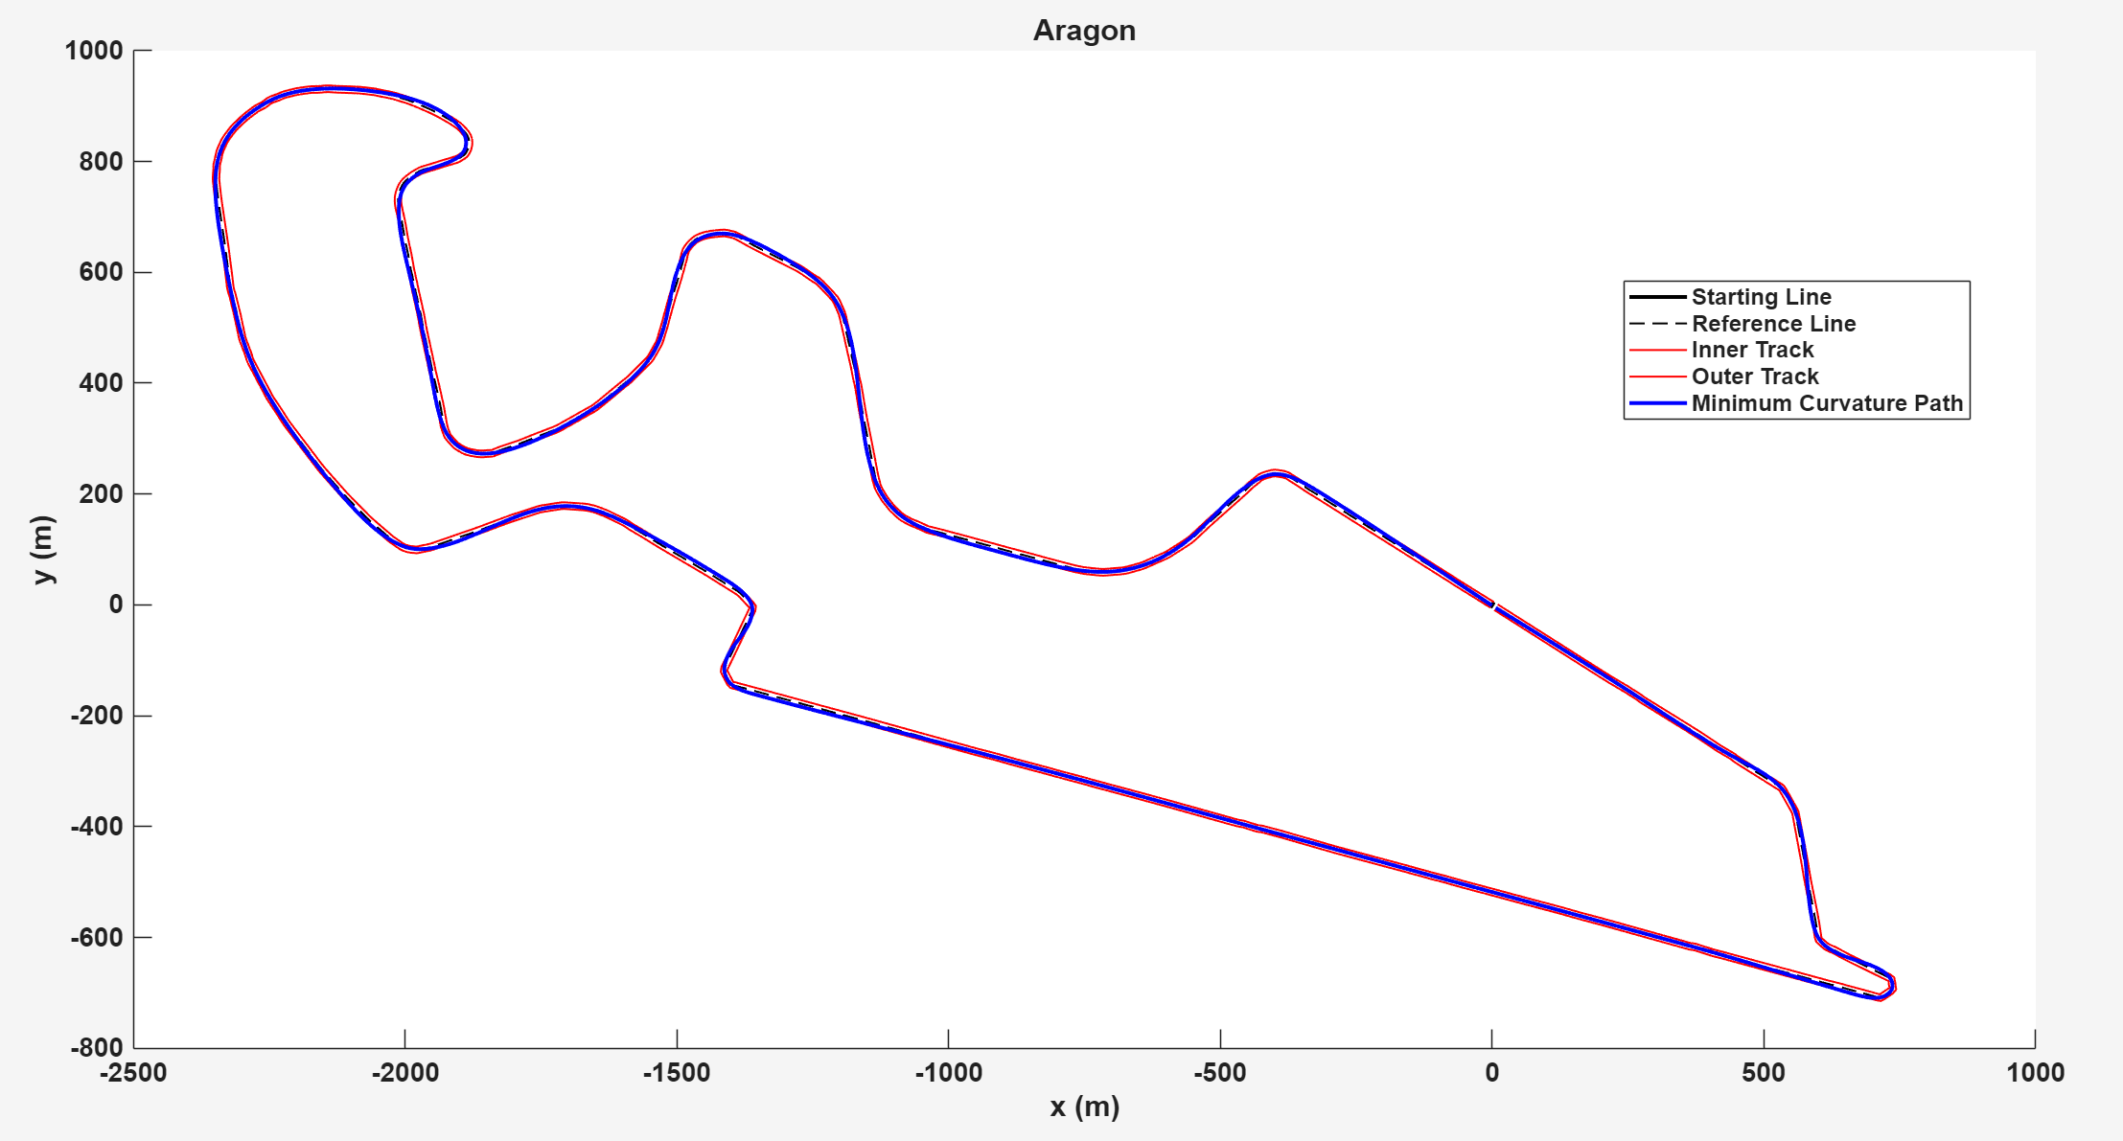
Figure 1 - Minimum curvature racing line.

Velocity solver

Parameter setup
This section covers the code referenced in Section 5.3.
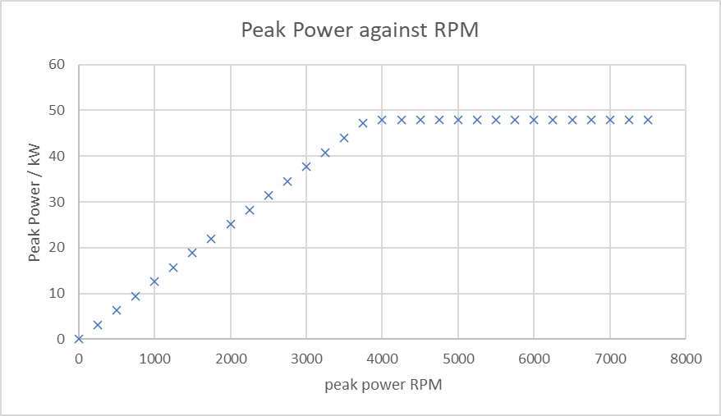
The maximum bike velocity is limited by the maximum rotational velocity of the motor. The ME1616 motor supplied by moto student has a peak power of 48 kW and maximum speed of 7500 rpm with a peak efficiency of 93%. The information supplied in the datasheet for this motor was used to approximate a power against RPM lookup table
Figure 2 - Peak power to Motor RPM lookup table
Peak Power / kW | RPM at peak power
0 | 0
3.142 | 250
6.283 | 500
9.425 | 750
12.566 | 1000
15.708 | 1250
18.85 | 1500
21.991 | 1750
25.133 | 2000
28.274 | 2250
31.416 | 2500
34.558 | 2750
37.699 | 3000
40.841 | 3250
43.982 | 3500
47.124 | 3750
48 | 4000
48 | 4250
48 | 4500
48 | 4750
48 | 5000
48 | 5250
48 | 5500
48 | 5750
48 | 6000
48 | 6250
48 | 6500
48 | 6750
48 | 7000
48 | 7250
48 | 7500

At the development stage of the Gen 1 Driving line simulation, Many of the design specifications of the bike had not been decided to initial estimate values were made using knowledge of competitor bikes, the previous Isle of Man TT bike parameters or conservative estimates:
Table 1 - Drive cycle physical parameters
Parameter | Value
Bike mass | 220 kg
Gear ratio (motor to rear wheel) | 3.68
Rear wheel diameter | 0.601 m
Drag coefficient | 0.4
Centre of gravity height | 0.45 m
Tyre - road friction coefficient | 1.00
Tyre thickness | 67.8 mm
Air density | 1.225 kgm^-3
Rolling resistance (velocity-independent) | 4e-03
Rolling resistance (velocity-dependent) | 2.5e-05
Brake rotor outer diameter | 0.32 m
Brake rotor inner diameter | 0m246 m
Brake rotor piston diameter | 3.39e-2 m
Number of brake pistons | 4
Brake friction coefficient | 0.4
Hydraulic brake line pressure | 1 MPa

As a safety factor, the bike mass is scaled to 242 kg (i.e. +10%) and clamps are set for a maximum linear velocity of 65 m/s (~234 km/h). Similarly, clamps are set on the lean angle and lean rate. For Gen 1 these values are approximates of 55º and 30º/s.

Idealised velocity limit
This section covers the code referenced in Sections 5.4 and 5.5.
The Gen 1 model relies on a point mass approximation of the bike’s motion; riding the bike at the limit of tyre slip to simplify simulation calculations as a no slip condition and provide an initial estimation of bike performance to begin development.
For each segment of the track the loop looks ahead to the next 1 to 40 segments (higher velocities look ahead further than at slow speeds and checks the tightest radius in those segments to later infer whether the bike needs to brake to avoid slipping off the track.
The idealised roll angle (Φ) for that radius at the bike’s current speed is computed with a correction for tyre thickness (Φ_{Δ}):
$$Φ=\tan^{-1}\left(\frac{v^{2}}{gr}\right)+ Φ_{Δ}$$
The rate of change of roll angle is tapered in the code to mimic the effect of inertia in the longitudinal axis. The Gen 1 model implements a maximum lean rate of 30ºs⁻¹ and a maximum lean angle of 55º from vertical. Above 70% of the maximum lean angle, a taper is applied to the rate of change of lean angle, this taper is determined using the square of the ratio between lean and maximum lean angle to give the following effective maximum lean rate (Section 5.4)
$${Φ^{'}}_{max eff}= {Φ^{'}}_{max }*\left(1-\frac{Φ}{Φ_{max}}\right)$$
The contact patch area is related to lean angle such that as lean angle increases the contact area will decrease. In the Gen 1 simulation this relationship is substituted with an effective friction coefficient to mimic the effects of the change in contact patch at higher lean angles.
Lean angle Φ (º) | Contact area A(Φ) (m²)
0 | 0.0204
5 | 0.0203
10 | 0.0201
15 | 0.0197
20 | 0.0192
25 | 0.0185
30 | 0.0177
35 | 0.0167
40 | 0.0156
45 | 0.144
50 | 0.0131
55 | 0.0177

$$μ_{eff}= μ*\cos\left(Φ\right)* \frac{A\left(Φ\right)}{A\left(0\right)}*\frac{F_{z}}{Mg}$$
The F_{z} / Mg term represents the normalised vertical load. $F_{Z}$ is dynamically calculated to account for both the rider’s lean angle and the track gradient angle derived from the elevation profile. On steep inclines or declines, the normal force is reduced ($F_{z}∝cosθ$) which reduces available traction.
The maximum velocity with which the bike can get round the corner without slipping is determined by this effective friction coefficient (μ_{eff})
$$v_{corner}= \sqrt{μ_{eff}gr}$$
This is then clamped to the mechanical speed limit of 65 m/s (7500 rpm) specified below to give an ideal velocity profile (Section 5.5).
$$v_{max}=\frac{7500 rpm}{Gear Ratio}* \frac{2π}{60}* r_{wheel}=65 m/s$$

Force driven velocity
This section covers the code referenced in Sections 5.6 and 5.7
To reach the idealised velocity profile a force driven model is used to apply an open throttle acceleration or full brake deceleration in addition to a drag force and rolling resistance approximation.
The bikes resistive forces are calculated at each segment (Aerodynamic drag, Rolling resistance, Gravitational resistance and braking force if needed)
Gravitational force is calculated based on the instantaneous slope of the track ($θ$). This force opposes motion during ascents and assists motion during descents:
$$F_{grav}=M*g*sin⁡(θ)$$
The rolling resistance Is calculated with a velocity dependent (B_{d}) and independent (A_{d}) component:
$$F_{roll}=mg(A_{d}+ B_{d}v)$$
Lateral force demand is found for the bike to round the segment curvature at its currant speed:
$$F_{lat}=\frac{mv^{2}}{r}$$
The Total available traction force at the tyres is also found using bike reaction force to the ground (F_{z}) and effective friction coefficient at the riders lean angle, then it is used to find the available longitudinal force by subtracting the square of the available lateral force from the square of the available force at the tyre:
$$F_{Tractive total}= μ_{eff}F_{z}$$
$$F_{long cap}= \sqrt{{F_{Tractive total}}^{2}- {F_{lat}}^{2}}$$
For deceleration, the Simulation scales a maximum braking force, calculated from parameters provided in Table 1, by how close the velocity is to the limiting velocity of the corner See Code in section 5.6. This can lead to delayed braking where the bike speed exceeds the limit of the corner temporarily, for a Gen 1 simulation however, this approximation is used to begin influencing design direction with validation of performance to be completed in greater detail and validity later in the design with more advanced sim generations and physical testing.
The longitudinal force is summed with the drag resistance, rolling resistance and gravitational component forces to calculate the acceleration of that segment and then summed to the velocity for the next segment iteration and calculates the time taken to reach the next segment to approximate an expected lap time by summating each segment time over the lap.
$$a=\frac{F_{long}-F_{drag}-F_{roll}-F_{grav}}{M}$$

A taper is applied to velocity as it applies max velocity to mimic what is expected in reality however without physical testing this taper is not tuned and remains a rudimentary approximation in the Gen 1 simulation.

Drive Cycle Results
The lap time of the model in a full throttle “Push” lap is simulated to be 146 (145.82) seconds (02:26 mins:secs) This is comparable to the lap times posted for MotoStudent teams of previous years ranging 138 seconds (02:18) to 160 seconds 02:40 [2].
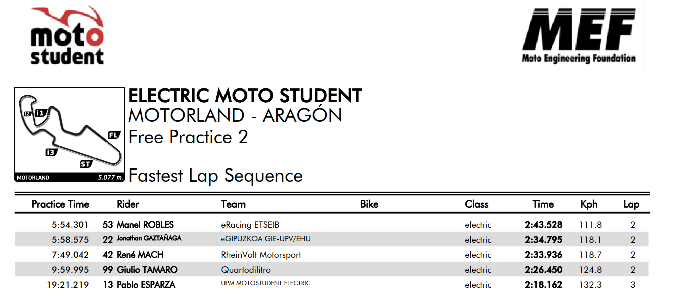

Velocity profile
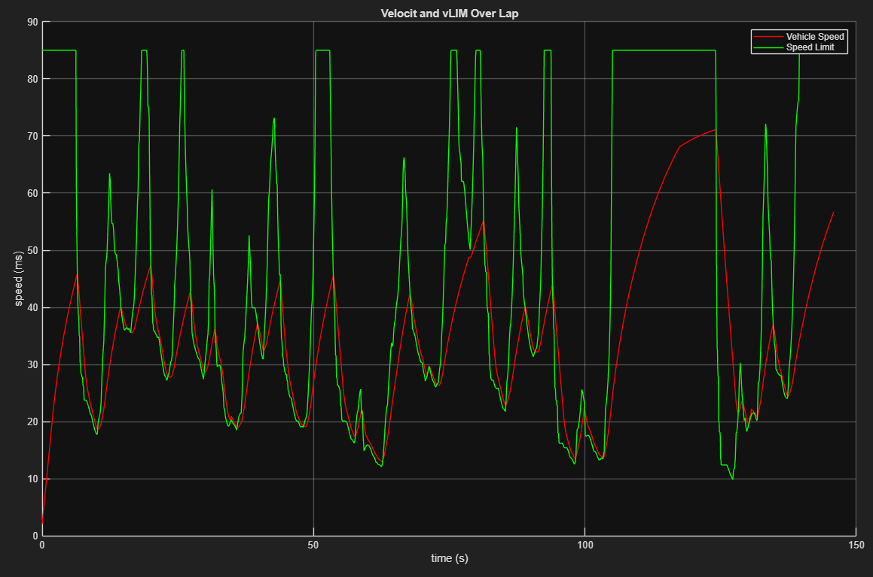
Figure 6 - Bike velocity in comparison to physical speed limit against time
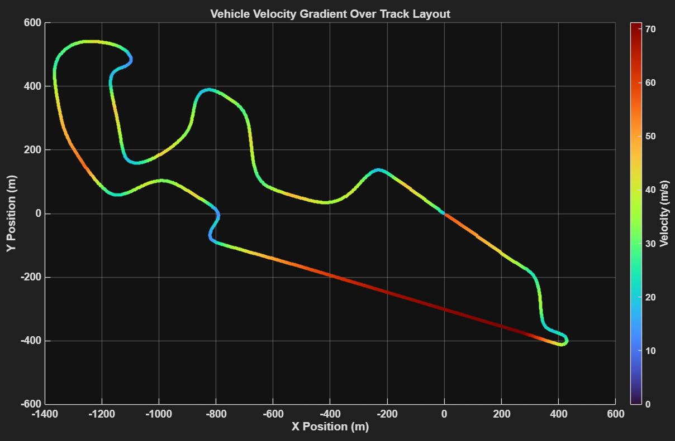
Figure 7 – Bike velocity around track geometry

Applied force
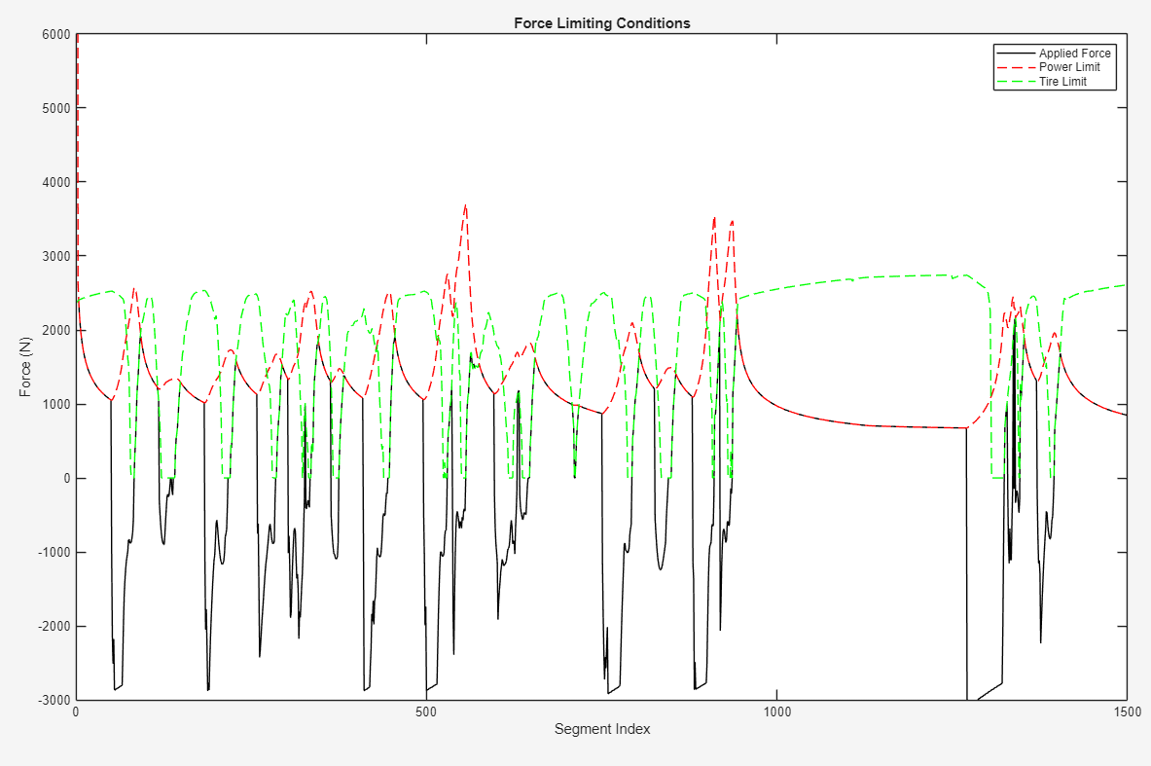

Lean angle
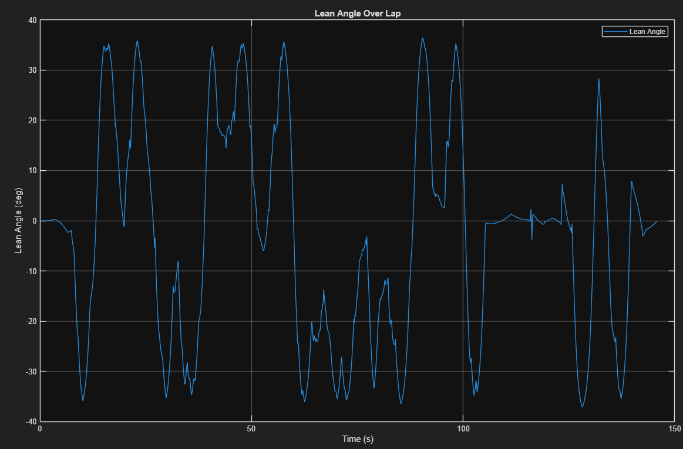

Energy Exchanges
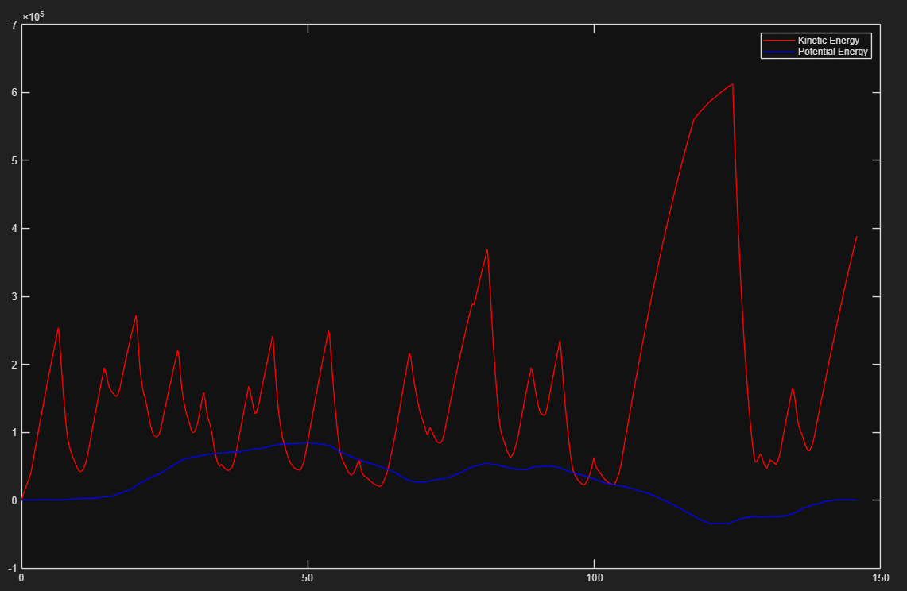

Matlab Code exerts

Track processing module (processTrack.m)

function [trackDataOut] = processTrack(filename)
%Acts as module to allow the code to take any track data just by calling a function
%% Processing track data
track = readmatrix('Aragon_converted_meters.csv');
name = 'Aragon';

% track data - first point repeated
data = track;

% x,y,z and track width data
y = data(:,1);
x = data(:,2);
twr = data(:,3);
twl = data(:,4);
z = data(:,5);

% smooths elevation to create a coherent gradient
z_smooth = smoothdata(z, 'gaussian', 25);

% higher no. of segments causes trajectory to follow the reference line
nseg = 1500;

% interpolate data to get finer curve with equal distances between each segment
pathXY = [x y];

stepLengths = sqrt(sum(diff(pathXY,[],1).^2,2)); % - prepares for interpolation, pythagorous theorem for even distances
stepLengths = [0; stepLengths]; % - starting point
cumulativeLen = cumsum(stepLengths); % - model length of track
finalStepLocs = linspace(0,cumulativeLen(end), nseg);
finalPathXY = interp1(cumulativeLen, pathXY, finalStepLocs);

% track centerline
xt = finalPathXY(:,1);
yt = finalPathXY(:,2);
zt = interp1(cumulativeLen, z_smooth, finalStepLocs, 'pchip')';

% track widths
twrt = interp1(cumulativeLen, twr, finalStepLocs,'spline')';
twlt = interp1(cumulativeLen, twl, finalStepLocs,'spline')';

% normal direction for each vertex
dx = gradient(xt);
dy = gradient(yt);
dL = hypot(dx,dy);

% uses the track width (6m) data to turn them into actual coordinates
xoff = @(a) -a.*dy./dL + xt;
yoff = @(a) a.*dx./dL + yt;

% offset data
offset = [-twrt twlt];
xin = xoff(offset(:,1));
yin = yoff(offset(:,1));
xout = xoff(offset(:,2));
yout = yoff(offset(:,2));

% Form delta matrices
delx = xout - xin;
dely = yout - yin;

% Store for plotting later
trackDataRaw = [xt yt xin yin xout yout];

MCP Optimisation (part of module)
%% Matrix Definition & MCP Solver
% GOAL: Find the smoothest path by minimizing curvature (Acceleration^2)
% Solves for 'a' (resMCP) which is the position of the bike along the track width
% a = 0 is innermost wall, a = 1 is outermost wall
% x(i) = Innermost + a*width of track
n = numel(delx);
H = zeros(n);
B = zeros(size(delx)).';

%% Builds H Matrix (cost matrix)
% Matrix defines the cost of the path's shape
% Expands the term (x(i-1) - 2x(i) + x(i+1))^2.
% - Diagonal terms (X X X): The "squared terms", penalty for sharp angles.
% - Off-diagonal terms (X X 0): The "cross terms" (2AB), reward for moving in line with neighbors (smoothing).
for i=2:n-1
% Previous neighbour interaction (i-1)
H(i-1,i-1) = H(i-1,i-1) + delx(i-1)^2 + dely(i-1)^2;
H(i-1,i) = H(i-1,i) - 2*delx(i-1)*delx(i) - 2*dely(i-1)*dely(i);
H(i-1,i+1) = H(i-1,i+1) + delx(i-1)*delx(i+1) + dely(i-1)*dely(i+1);

% Current point interaction (i) - Main penalty
H(i,i-1) = H(i,i-1) - 2*delx(i-1)*delx(i) - 2*dely(i-1)*dely(i);
H(i,i) = H(i,i ) + 4*delx(i)^2 + 4*dely(i)^2;
H(i,i+1) = H(i,i+1) - 2*delx(i)*delx(i+1) - 2*dely(i)*dely(i+1);

% Next neighbour interaction (i+1)
H(i+1,i-1) = H(i+1,i-1) + delx(i-1)*delx(i+1) + dely(i-1)*dely(i+1);
H(i+1,i) = H(i+1,i) - 2*delx(i)*delx(i+1) - 2*dely(i)*dely(i+1);
H(i+1,i+1) = H(i+1,i+1) + delx(i+1)^2 + dely(i+1)^2;
end

%% Builds B Matrix (geometric reference)
% Encodes the curvature of the inner wall of the track
% B = (Curvature of inner wall) * (Direction of track width)
% Acts as a geometric constraint the solver has to work with
for i=2:n-1
B(1,i-1) = B(1,i-1) + 2*(xin(i+1)+xin(i-1)-2*xin(i))*delx(i-1) + 2*(yin(i+1)+yin(i-1)-2*yin(i))*dely(i-1);
B(1,i) = B(1,i) - 4*(xin(i+1)+xin(i-1)-2*xin(i))*delx(i) - 4*(yin(i+1)+yin(i-1)-2*yin(i))*dely(i);
B(1,i+1) = B(1,i+1) + 2*(xin(i+1)+xin(i-1)-2*xin(i))*delx(i+1) + 2*(yin(i+1)+yin(i-1)-2*yin(i))*dely(i+1);
end

% Constrants: 'a' must be between 0 and 1
lb = zeros(n,1);
ub = ones(size(lb));

% Forces start and end points to match
Aeq = zeros(1,n); Aeq(1)=1; Aeq(end)=-1; beq=0;

%% Solver
% Solves the linear system H * a + B = 0
% Finds values of a (resMCP) that minimise cost close to 0
options = optimoptions('quadprog','Display','off');
[resMCP,~,~,~] = quadprog(2*H,B',[],[],Aeq,beq,lb,ub,[],options);

% Calculates final coordinates : Inner wall + a * Width_vector
xresMCP = xin + resMCP.*delx;
yresMCP = yin + resMCP.*dely;

Velocity solver setup
%% Constants
P_max = 48 * 1000; % Max power in watts (converted from kW to W)
finalDriveRatio = 3.68;
wheelRadius = 0.601/2; % meters
frontalArea = 0.3; % square meters
cd = 0.4; % Drag coefficient
rho = 1.225; % kg/m^3
tireFrictionCoeff = 1; % Maximum friction coefficient
carMass = 220; % kg
h_cog = 0.45; %Cog bike
t_tyre = 67.8/1000; % tyre thickness bike
maxLeanDeg = 55;
maxLeanRad = deg2rad(maxLeanDeg);
maxLeanRateDeg = 30; % e.g. 60 deg/s, tune as you like
maxLeanRate = deg2rad(maxLeanRateDeg); % [rad/s]
g = 9.81; % Gravitational acceleration in m/s²
Ad = 0.004; % Rolling resistance coefficient (velocity-independent)
Bd = 0.000025; % Rolling resistance coefficient (velocity-dependent)
Me_scalingfactor = 1.1;
M_effective = carMass * Me_scalingfactor;
speed_limit = 85;
Fz_prev = M_effective * g;
useLeanRateClamp = true;
useMaxLeanClamp = true;

% Power curve data
PPeak_kW = [0, 3.142, 6.283, 9.425, 12.566, 15.708, 18.85, 21.991, 25.133, 28.274, 31.416, ...
34.558, 37.699, 40.841, 43.982, 47.124, 47.8, 48];
RPM_peakPower = [0, 250, 500, 750, 1000, 1250, 1500, 1750, 2000, 2250, 2500, 2750, 3000, ...
3250, 3500, 3750, 4000, 7500];

% Use peak power curve
motorRPM = interp1(PPeak_kW, RPM_peakPower, P_max / 1000, 'linear', 'extrap');
curveType = 'Peak';

% Calculate max velocity
%maxV = wheelRadius * 2 * pi * (motorRPM / finalDriveRatio) / 60;
maxV = 85; % - kept as 85 for now

% Display results for power/vel
fprintf('Using %s Power Curve\n', curveType);
fprintf('Motor RPM at P_max = %.1f kW: %.2f RPM\n', P_max / 1000, motorRPM);
fprintf('Estimated max vehicle speed: %.2f m/s (%.2f km/h)\n', ...
maxV, maxV * 3.6);

%% Initialize starting conditions
velocity = 0.1; % Initial velocity in m/s
time = 0; % Initial time
dt = 0.1;
dt_seg = 0.2;

% Define arrays to store velocity and time for plotting
velocityProfile = [];
timeProfile = [];
velocityTrack = []; % Store velocity at each track point for gradient plot
accel = [];
Fcommm = [];

Lean angle solver
%% Simulation loop with power-sensitive lap time scaling
for i = 1:length(xresMCP_laps)-1 % One less due to diff

turnSign = TSignProfile(i);
r_turn = RProfile(i);

% --- velocity-dependent look-ahead size (keep your scaling) ---
% Simulates rider vision
% Low speed: Look immediately ahead (Nmin)
% High speed: Look far ahead to anticipate braking (Nmax)
Nmin = 1;
Nmax = 40;
v_ref = min(speed_limit, maxV);

% Interpolates look ahead distance based on speed (alpha is ratio 0-1)
alpha = max(0, min(velocity / v_ref, 1));
Nlook = round(Nmin + (Nmax - Nmin)*alpha);

% indices for look-ahead window
Npts = length(RProfile);
idxEnd = min(i + Nlook, Npts);

% window of radii ahead (including current)
R_window = RProfile(i:idxEnd);

% ignore straights / invalid
R_valid = R_window(isfinite(R_window) & (R_window > 0));

if isempty(R_valid)
R_min_forward = inf; % no real corner ahead
else
R_min_forward = min(R_valid); % tightest corner in the window
end

% local timestep (avoid /0)

% Drag and rolling resistance
F_drag = 0.5 * cd * rho * frontalArea * velocity^2;
F_roll = carMass * g * (Ad + Bd * velocity);

% --- Roll angle from Cossalter 4.1.1 & 4.1.2 ---

if isfinite(r_turn) && r_turn > 0
phi_i = atan(velocity^2/(g*r_turn)); % ideal roll angle
else
phi_i = 0;
end

% extra roll due to tyre thickness
if (h_cog > t_tyre) && (phi_i ~= 0)
phi_delta = asin( (t_tyre * sin(phi_i)) / (h_cog - t_tyre) );
else
phi_delta = 0;
end

phi_mag = phi_i + phi_delta; % magnitude of effective roll, always ≥0

if turnSign > 0 % say this corresponds to a LEFT turn geometrically
phi_signed_target = -phi_mag; % left = negative
elseif turnSign < 0 % RIGHT turn
phi_signed_target = phi_mag; % right = positive
else
phi_signed_target = 0;
end

if i == 1
phi_prev = 0;
end

phi_target = phi_signed_target; % from previous section

% --- B) Clamp max lean magnitude ---
if useMaxLeanClamp
phi_target = max(min(phi_target, +maxLeanRad), -maxLeanRad);
end

% === Lean Rate Taper (Stability control) ===
% As bike approaches maximum lean angle, it becomes harder to lean more
% Taper the roll rate to 0 as max lean is approached to prevent snapping or overshoot

% Calculates how close we are to physical limit (0 = upright, 1 = max lean)
phi_ratio = abs(phi_prev) / (0.7* maxLeanRad); %tune 0.xx value to change taper start point
phi_ratio = min(max(phi_ratio,0),1);

% Quadratic taper to roll rate
p = 2;
taper = 1 - phi_ratio^p; % taper factor: 1 (full movement) -> 0 (no movement)
maxLeanRate_eff = maxLeanRate * taper;

% === Lean Rate Limiting ===
% Ensures bike cannot roll faster than physically possible (maxLeanRate_eff)
if useLeanRateClamp
maxDeltaPhi = maxLeanRate_eff * dt_seg;
dphi = phi_target - phi_prev;

if abs(dphi) > maxDeltaPhi
phi = phi_prev + maxDeltaPhi * sign(dphi);
else
phi = phi_target;
end
else
phi = phi_target;
end

if i == 1
leanProfile = zeros(length(xresMCP_laps)-1,1);
end

leanProfile(i) = phi;
phi_prev = phi;

Velocity limit based on corner curvature
%Motorbike Tyre Data
leanDeg_AreaTable = [0 5 10 15 20 25 30 35 40 45 50 55]; %[deg]
contactAreaTable = [0.0204 0.0203 0.0201 ...
0.0197 0.0192 0.0185 ...
0.0177 0.0167 0.0156 ...
0.0144 0.0131 0.0117]; % [m^2]

A_contact = interp1(leanDeg_AreaTable, contactAreaTable, rad2deg(abs(phi)), 'linear', 'extrap');
if i == 1
Aprofile = zeros(length(xresMCP_laps)-1,1);
end

Aprofile(i) = A_contact;

A0 = contactAreaTable(1);
mu_adjust = ((A_contact)/A0);
mu_eff = min(1, tireFrictionCoeff * cos(abs(phi)) * mu_adjust * (Fz_prev/(M_effective * g)));

if i == 1
Muprofile = zeros(length(xresMCP_laps)-1,1);
end

Muprofile(i) = mu_eff;

% Lateral force demand, calculates how much grip is spent on turning
if r_turn ~= Inf
F_lat = M_effective * velocity^2 / r_turn;
else
F_lat = 0;
end

%Elevation
dz = zt(i+1) - zt(i);
ds_seg = segmentLengths(i);

sin_theta = dz / sqrt(ds_seg^2 + dz^2);

% Max total tire force (traction circle)
% Total grip available = Normal Force * Friction coeff
Fz = (M_effective * g * cos(phi) * cos(asin(sin_theta)) + F_drag);
F_tire_total = (mu_eff * Fz);

Fz_prev = Fz;

if i == 1
FTyreprofile = zeros(length(xresMCP_laps)-1,1);
end

FTyreprofile(i) = F_tire_total;

% --- Cornering speed limit from mu and radius ---
if isfinite(r_turn) && r_turn > 0
v_corner_mu = sqrt(mu_eff * g * R_min_forward); % lateral friction-limited cornering speed
else
v_corner_mu = speed_limit;
end

% combine with your global limit
v_limit = min(v_corner_mu, speed_limit);

if i == 1
VLIMprofile = zeros(length(xresMCP_laps)-1,1);
end

VLIMprofile(i) = v_limit;

Braking force solver
%% Brake Force Solver
% --- Brake system parameters (front wheel only here) ---
rotor_OD = 0.320; % [m]
rotor_ID = 0.246; % [m]
R_eff = 0.5*(rotor_OD + rotor_ID); % effective pad radius

D_piston = 33.9e-3; % [m]
N_piston = 4;
A_piston = N_piston * pi*(D_piston/2)^2; % total piston area

mu_pad = 0.4; % pad friction coeff (guess)
lineP_max = 1e6; % [Pa] ~10 bar, tune to taste

T_brake_max = 2 * mu_pad * lineP_max * A_piston * R_eff; % factor 2: two pads
F_brake_wheel_max = T_brake_max / wheelRadius; % [N] at tyre

…

% Brake modulation:
% If slightly overspeed, brake gently. If signif overspeed (>xm/s) full brake.
brakeBandwidth = 7; % [m/s], tune this value (speed when 100% braking applied)
brakeScale = min(1, vdelta / brakeBandwidth);

Force Driven acceleration
% --- Remaining grip available for accel/braking ---
% Finite amount of grip, calculates how much required to hold turn (F_lat).
% Remaining grip (F_long_cap) is available for accel/braking.
% If corner too hard, F_long_cap is 0 so no braking or accel
F_long_cap = sqrt(max(F_tire_total^2 - F_lat^2, 0)); % >=0

% --- Simple "driver": decide whether to gas or brake ---
% look at how far above / below the local speed limit we are

if velocity < v_limit
% ACCELERATION PHASE
% Below limit: Use max engine power available
F_cmd = F_power_limit;
elseif velocity > v_limit % + margin
% BRAKING PHASE
% Above limit: Apply brakes scaled by urgency, drag and rolling assist braking
F_cmd = (-F_brake_wheel_max * brakeScale) - F_drag - F_roll; % full brake request (negative)
end

% --- Apply traction-circle and power/brake limits with correct sign ---
if F_cmd >= 0
% accelerating: limited by traction & power
F_long = min([F_cmd, F_long_cap, F_power_limit]);
else
% braking: negative, limited by traction & brake system
F_long = F_cmd; %max(F_cmd, -F_long_max_brake); % most negative allowed
end

if i == 1
FCMDprofile = zeros(length(xresMCP_laps)-1,1);
end

FCMDprofile(i) = F_cmd;

% Grav force
F_grav = M_effective * g * sin_theta;

% Acceleration
dv = (F_long - F_drag - F_roll - F_grav) / M_effective;

% Only taper during acceleration, never during braking
if dv > 0
V66 = min(speed_limit, maxV) * 0.8;

if velocity > V66
taper = 1 - (velocity / min(speed_limit, maxV))^2;
taper = max(taper, 0);
dv = dv * taper;
end
end

velocity = velocity + dv * dt_seg;

% Clamp velocity at max achievable or speed limit
velocity = max(0, min(velocity, min(speed_limit, maxV))); % clamp, no negative speeds

ds = segmentLengths(i); % segment length
dt_seg = ds / velocity;

% Store and update
velocityProfile = [velocityProfile; velocity];
timeProfile = [timeProfile; time];
velocityTrack = [velocityTrack; velocity];
accel = [accel; dv];

%Lap Time
ds = segmentLengths(i); % segment length
time = time + (ds/velocity);

if i == 1
DTprofile = zeros(length(xresMCP_laps)-1,1);
end

DTprofile(i) = dt_seg;

F_power_array(i) = F_power_limit;
F_remain_array(i) = F_long_cap;
F_applied(i) = F_long;
end

References

[1] | V. Cossalter, Motorcycle Dynamics, 2006.
[2] | MotoStudent, “Electric Moto Student Free Practice 2 Fastest Lap Times,” [Online]. Available: http://motorlandaragon.alkamelsystems.com/Results/06_2025/04_MOTOSTUDENT/574_ELECTRIC%20MOTO%20STUDENT/202510181630_Free%20Practice%202/17_FastestLapSequence_Free%20Practice%202.PDF.

Appendix

Aragon track data
General\Engineering\12 Simulation\General\GEN 1 Drice Cycle Sim\Aragon_converted_meters.csv

MotoStudent ME1616 motor data sheet
General/Engineering/4 Standards and Regulations/MotoStudent Regulations/Motor Specs -MS2223 CIRCE INFO.v1.1.pdf

Full Gen-1 MATLAB script
General\Engineering\12 Simulation\General\GEN 1 Drice Cycle Sim\ Drivecyclegeneratorv3_DEVRELEASE.m

